TOURIST ROUTE: BOGOTÁ AND ITS SAVANNA

Day 1. Arrival to Bogotá
Arrival at the airport, reception and transfer to the hotel. Accommodation.

Day 2. Visit to the city and Monserrate
Breakfast at the hotel. Visit the historical area of Bogotá, neighborhood La Candelaria and the museum of Gold, where there is a selection of pre-Columbian gold and other metal alloys. Lunch. Visit to Monserrate, one of the symbols and the most tourist places in the city. It is a hill of 3152 meters high, where a Catholic church was built in 1925. Ascent by cable car, visit and tour. Dinner, back to the hotel.


Day 3. Bogotá- Zipaquirá- Sopó
Breakfast at the hotel. Departure by the north of the city towards Zipaquirá. Entrance to the Salt Cathedral, an underground catholic church built within the tunnels of a salt mine to 200 meters underground, close to the village. Tour and lunch. After, visit to Sopó and the Alpina Cabin, place where the dairy products of the Colombian Alpina Company are manufactured. A big variety of products to buy and a beautiful park around where you can enjoy the freshly desserts. Return to Bogotá. Dinner at the hotel.
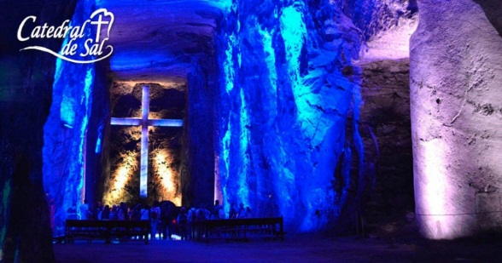

Day 4. Usaquén- 93 park- Andrés Carne de Res D.C. Restaurant
Visit to Usaquén, old village of the Altiplano that became Bogota's neighborhood in 1954. On the eastern side of its main square stands the Church of Santa Bárbara de Usaquén, dating from the middle of the 17th century. Around it is possible to walk through narrow streets, buy handicrafts and visit elegant restaurants and typical food, as well as bars and other locals. Lunch. After we will visit to the 93 park, a commercial and recreational park in the north of Bogotá, one of Bogotá's most popular shopping, night club and restaurant areas. At night, we will take the farewell dinner at Andrés Carne de Res, the most famous restaurant in Bogotá.
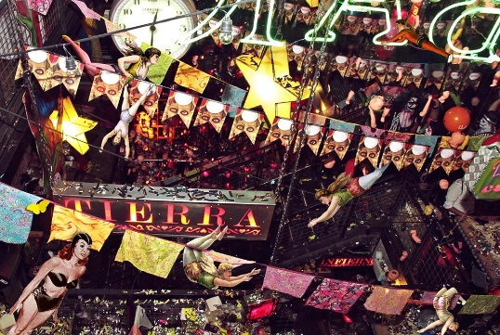

Day 5. Return
Breakfast at the hotel. At the indicated time transfer from the hotel to the airport for the return.

THE PLAN INCLUDES
- Transportation Tourism
- Accommodation hotels category tourist superior or superior
- Income to all tourist sites and parks described in the program
- Insurance and medical Assistance
- Tour guide
- Food described in the program
- Transfers airport-hotels-Airport

THE PLAN NOT INCLUDES
- Personal expenses or any expense not described in the program

RATES PER PERSON IN AMERICAN DOLLARS:

2 PAX MINIMO USD 1.255
4 A 6 PAX USD 959
8 A 10 PAX USD 810
12 A 15 PAX USD 760
16 EN ADELANTE USD 735

** RATES SUBJECT TO CHANGE WITHOUT PRIOR NOTICE AND AVAILABILITY AT THE TIME OF BOOKING **
GENERAL CONDITIONS
- Apply supplement in single room.
- Services in the destination not taken by the passenger are not refundable, independent of the cause that originate it.
- To reserve a deposit of 20% of the value of the program is required, which is paid the total payment. The registration fees are deposits demanded by the hotels and transports as guarantee of fulfillment, (excepting cases of force greater verifiable).
- The total payment must be cancelled 15 days before the scheduled departure date for the trip.

CANCELLATION AND MODIFICATION COSTS
- Cancellations between 15 and 8 days before departure you have 50% of expenses per person on the sale price.
- Cancellations between 8 and 1 day before departure you have 100% of expenses per person on the sale price.
- The non-presentation on the day of the exit of the circuit will incur in 100% of the total expenses.

IMPORTANT NOTES
- Upon receipt of the deposit that the passenger delivers, we understand that the passenger has learned and accepted each of the conditions, payment policies and cancellation.

LIABILITY CLAUSES

SOÑAR & VOLAR VIAJES Y TURISMO S.A.S. RNT No. 27539 issued by the Ministry of Commerce, industry and tourism, is covered by the regime of responsibility and that establishes the law 300/96 and D.R. 1075/95. Decree 053 of 2002 and other statutory decrees. We declare that we act only as intermediaries between travelers and entities or people called to facilitate the services indicated on the itineraries. Consequently, we disclaim all liability to the user or traveler by event of force majeure or fortuitous case, action or omission of third parties or of the traveler who may incur before or during the trip.

SOÑAR & VOLAR VIAJES Y TURISMO S.A.S., is accepted by the law 679 of 2001 by which the statute is issued to prevent and counteract exploitation pornography and sexual tourism with minors.

