COLONIAL TOURIST ROUTE

Day 1. Arrival to Bogotá
Arrival at the airport, reception and transfer to the hotel. Accommodation.

Day 2. Visit to the city and Monserrate
Breakfast at the hotel. Visit the historical area of Bogotá, neighborhood La Candelaria and the museum of Gold, where there is a selection of pre-Columbian gold and other metal alloys. Lunch. Visit to Monserrate, one of the symbols and the most tourist places in the city. It is a hill of 3152 meters high, where a Catholic church was built in 1925. Ascent by cable car, visit and tour. Dinner, back to the hotel.
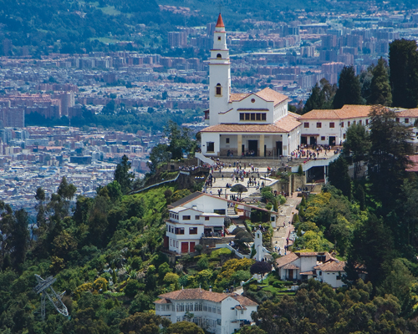

Day 3. Bogotá- Zipaquirá- Sopó
Breakfast at the hotel. Departure by the north of the city towards Zipaquirá. Entrance to the Salt Cathedral, an underground catholic church built within the tunnels of a salt mine to 200 meters underground, close to the village. Tour and lunch. After, visit to Villa de Leyva, a colonial village full of stories and legends with a beautiful architectonic preservation. Accommodation and dinner at the hotel.
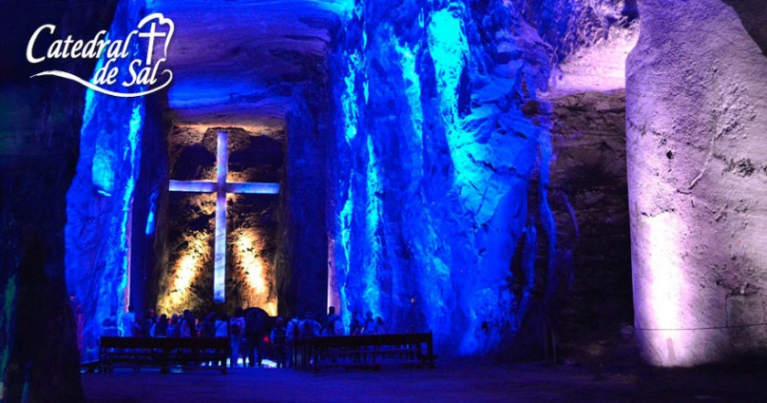

Day 4. Villa de Leyva – Tunja – Paipa
Breakfast at the hotel. Visit to Villa de Leyva, main plaza /square and other attractions. After start the tour to Tunja, the capital of Boyacá, Tunja is particularly noted for its colonial churches. The town also has an imposing central square, the Plaza de Bolívar and elegant mansions adorned with some of South America's most unique artwork. Lunch, continue travel to Paipa, another attraction of the department where you can visit El Pantano de Vargas, Plaza Central and others. Accommodation at the hotel where you can take a thermal bathroom. Dinner at hotel.
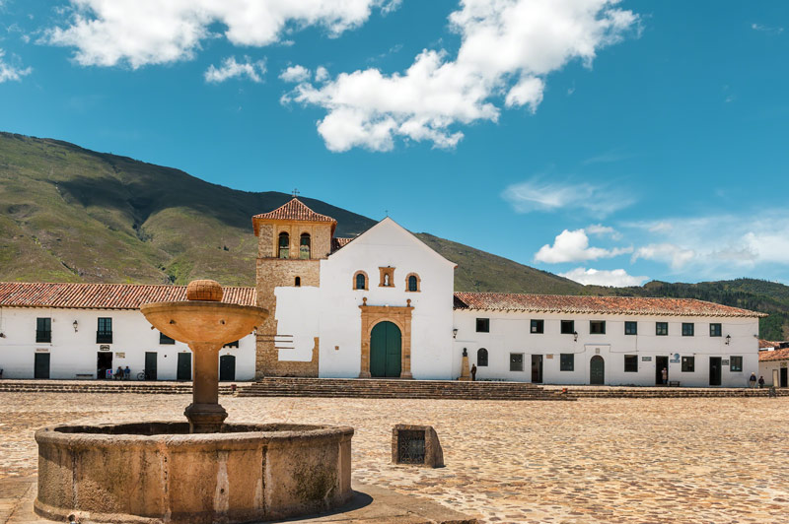

Day 5. Paipa – San Gil
Breakfast at the hotel. Begin the journey to destination to San Gil, tourist capital of Santander and famous because of extreme sports. Lunch. Accommodation at the hotel. In the afternoon visit to Gallineral Park and The principal park. At night dinner at the hotel.

Day 6. San Gil – Barichara – Guane
Breakfast at the hotel. Trip to Guane, village with a lot of history wealth and precious places of colonial architecture. Then lunch and visit to Barichara which is locate one hour away from Guane. Barichara is considered the most beautiful village in Colombia, which stands out for its white colonial houses, church and cobbled streets. Finally, dinner at hotel.
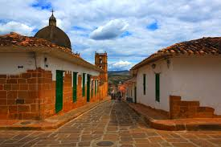

Day 7. San Gil – Chicamocha Park
Breakfast at hotel. Visit to Chicamocha Nacional Park, also call Panachi.
It is one of the few natural parks in Colombia dedicated to ecotourism. It was opened to the public on Saturday, December 2, 2006. Entrance, visit and tour by cable car. Typical Santanderiano Lunch. Then continue to Bucaramanga, The beautiful city. Accommodation. Dinner at hotel.
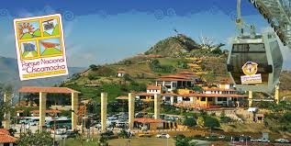

Day 8. Bucaramanga – Cerro El Santisimo y Giron
Breakfast at the hotel. Visit to Cerro del Santisimo, located in floridablanca, is the main attraction of the Ecopark. From the top you have the possibility to appreciate a magnificent landscape. Lunch. AT the afternoon visit to Giron, a small village where visit to the principal plaza and the Cathedral. At night dinner and accommodation at hotel.
Day 9. Bucaramanga – Bogotá
Breakfast at the hotel. After the indicated time transfer from the hotel to airport fort the return.
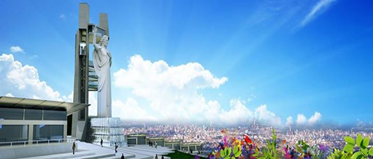

THE PLAN INCLUDES
- Transportation Tourism
- Accommodation hotels category tourist superior or superior
- Income to all tourist sites and parks described in the program
- Insurance and medical Assistance
- Tour guide
- Food described in the program
- Transfers airport-hotels-Airport

THE PLAN NOT INCLUDES
- Personal expenses or any expense not described in the program

RATES PER PERSON IN AMERICAN DOLLARS:

FULL PLAN 9 DAYS
2 PAX MINIMO USD 1.893
4 A 6 PAX USD 1.678
8 A 10 PAX USD 1.584
12 A 15 PAX USD 1.489
16 EN ADELANTE USD 1.454

PLAN 6 DAYS (DAY5 RETURN BOGOTA MAS NIGHT OF ACCOMMODATION IN BOGOTA)
2 PAX MINIMO USD 1.514
4 A 6 PAX USD 1.325
8 A 10 PAX USD 1.148
12 A 15PAX USD 1.088
16 EN ADELANTE USD 1.063

** RATES SUBJECT TO CHANGE WITHOUT PRIOR NOTICE AND AVAILABILITY AT THE TIME OF BOOKING **

GENERAL CONDITIONS
- Apply supplement in single room.
- Services in the destination not taken by the passenger are not refundable, independent of the cause that originate it.
- To reserve a deposit of 20% of the value of the program is required, which is paid the total payment. The registration fees are deposits demanded by the hotels and transports as guarantee of fulfillment, (excepting cases of force greater verifiable).
- The total payment must be cancelled 15 days before the scheduled departure date for the trip.

CANCELLATION AND MODIFICATION COSTS
- Cancellations between 15 and 8 days before departure you have 50% of expenses per person on the sale price.
- Cancellations between 8 and 1 day before departure you have 100% of expenses per person on the sale price.
- The non-presentation on the day of the exit of the circuit will incur in 100% of the total expenses.

IMPORTANT NOTES
- Upon receipt of the deposit that the passenger delivers, we understand that the passenger has learned and accepted each of the conditions, payment policies and cancellation.

LIABILITY CLAUSES

SOÑAR & VOLAR VIAJES Y TURISMO S.A.S. RNT No. 27539 issued by the Ministry of Commerce, industry and tourism, is covered by the regime of responsibility and that establishes the law 300/96 and D.R. 1075/95. Decree 053 of 2002 and other statutory decrees. We declare that we act only as intermediaries between travelers and entities or people called to facilitate the services indicated on the itineraries. Consequently, we disclaim all liability to the user or traveler by event of force majeure or fortuitous case, action or omission of third parties or of the traveler who may incur before or during the trip.

SOÑAR & VOLAR VIAJES Y TURISMO S.A.S., is accepted by the law 679 of 2001 by which the statute is issued to prevent and counteract exploitation pornography and sexual tourism with minors.

